

**CHURCHLANDS SENIOR HIGH SCHOOL**

**MATHEMATICS SPECIALIST 3,4 TEST 1 SECTION TWO 2016 Year 12**

**Calculator Section**

**Chapters 1, 2, 3 and 5**

**Name________________________________ Time: 35 minutes**

**Total: 35 marks**

1. [1, 5, 3 marks]

(a) State the exact value of ${(2+2\sqrt{3}i)}^{4}$ in **Cartesian form**. (1 mark)

(b) Hence determine exact values for all the roots of $z^{4}=-8-8\sqrt{3}i$. (5 marks)

(c) Sketch all the roots from (b) on the Argand diagram below. Identify all the important features. (3 marks)

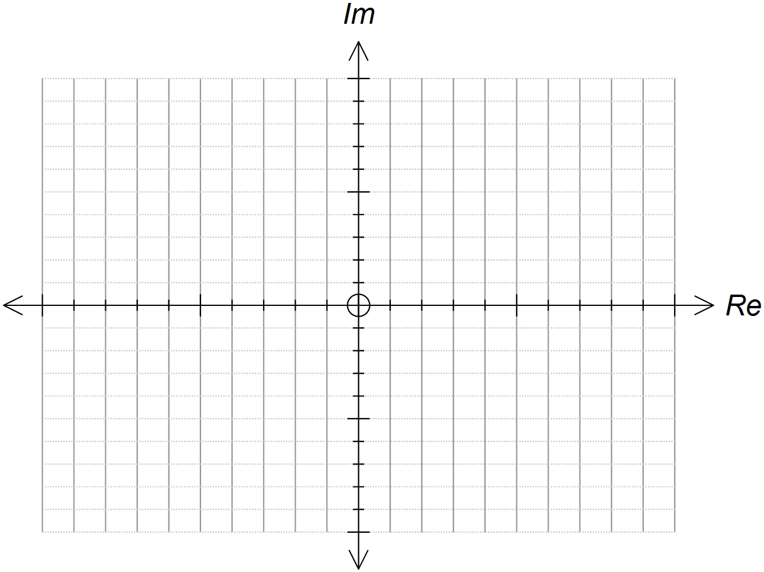

2. [2, 3, 2 marks]

Sketch the following regions in the complex plane.

(a) . (2 marks)



(b) . (3 marks)



(c) For the region in (b) above, state the minimum value of . (2 marks)

3. [6, 2 marks]

(a) Use de Moivre’s Theorem to solve $z^{5}=-iz$  
Give your answers in the form $rcisθ$ where $r≥0$ and $-π<θ≤π$  
[To obtain full marks for this question, you must show clearly the use of  
de Moivre's Theorem.]

(b) An exact solution to $z^{5}=-iz$ is $z=(\frac{-\sqrt{2-\sqrt{2}}}{2})+(\frac{-\sqrt{2+\sqrt{2}}}{2}) i$

Given that $cosθ=(\frac{-\sqrt{2-\sqrt{2}}}{2})$, use your answer in (a) and the above solution to $z$ to show that $θ=-\frac{5π}{8}$. Explain clearly how you arrived at your answer.

4 [4, 3, 3 marks]

(a) Express each of the following in polar form such that $r≥1$ and $0≤θ≤2π$.(4)



${(1-i)}^{5}$

${(-\sqrt{3}-i)}^{4}$

${(-1+i\sqrt{3})}^{}$

${(-2+2i)}^{3}$

(b) **Hence,** simplify $\frac{{(1-i)}^{5}{(-\sqrt{3}-i)}^{4}}{(-1+i\sqrt{3}){(-2+2i)}^{3}}$ giving your answer in Cartesian form.

Your working steps must show clearly how you multiply and divide complex numbers expressed in polar form. (3)

(c) The complex number is given such that $\overline{z}=\frac{-1-i}{1-\sqrt{3}i}$.

Find $z$ $and,$ $\frac{{\left|z\right|}^{2}}{\overline{z}}$ and hence state a relationship between them. (3)